|  |  |  |  |
| --- | --- | --- | --- |
| **Revision** | **Release Date** |  | **Description of Changes** |
| 2.0 | 01-April-2021 | • | Regional sections combined in Global sections for identical items |
|  |  | • | Global check list created |
|  |  | • | Additional illustrations added throughout document |
|  |  | • | Regional North America Mexico ergonomic weight changed to 30 lbs (15kgs) |
|  |  | • | Global Check list added, North America Check list removed |
|  |  | • | Europe central email address added |
|  |  | • | Added requirement that all solid wood packaging in Europe be ISPM-15 compliant |
|  |  | • | Updated responsibility of supplier to obtain permission to ship in back-up packaging |
| 3.0 | 01-October-2021 | • | General Packaging guidelines acc. environmental aspects updated (4.1) |
|  |  | • | Link updated (4.29.4) |
|  |  | • | Removed Johnson Controls letter, renumbered section 4.29 after 4.29.4 (4.29.5) |

|  |  |  |  |
| --- | --- | --- | --- |
| **Prepared** | | **Approved** | **Released** |
| **Process Leader** | **Subject Matter Expert** | **Process Champion** | **BOS Team** |
| Carole Muraske | Nicholas Adair | Kelli Carney |  |
| Approval records maintained by BOS Team | | |  |

# 1.0 Purpose

The purpose of the Global Supplier Standards Manual is to communicate Adient packaging requirements to the suppliers. It is the expectation of Adient that all suppliers of Direct Materials and quality relevant indirect suppliers comply with all of the requirements and expectations documented in this manual.

**2.0 Scope**

This standard applies to all Adient 3rd party suppliers.

# 3.0 Responsibility

The Part Supplier is responsible for:

* Adhering to the process for packaging selection outlined in this document
* Submission for Packaging Plan through Adient Packaging Data Form System

Master files are stored electronically and are available to all team members. Printed copies of the master files are for reference only.

# 4.0 Adient Global Supplier Packaging Standards & Requirements

The following supplier requirements and resources are outlined in this document:

|  |  |  |
| --- | --- | --- |
| Section | Topic | Page |
| 4.1 | General Adient Global Packaging Guidelines for all regions | 3 |
| 4.2 | Adient Supplied Returnable Packaging General Guidelines | 4 |
| 4.3 | Packaging Standards for Transoceanic shipments | 5 |
| 4.4 | Export Expendable Packaging standards for Overseas Shipments | 5 |
| 4.5 | Corrosion Prevention | 6 |
| 4.6 | Component/Production Labeling Requirements | 6 |
| 4.7 | Global Check list of the expectations | 6 |

Packaging is required to:

* Ensure part-quality throughout the supply chain (protect from dust, dirt, abrasion, etc.)
* Permit safe and ergonomic friendly for efficient handling, shipping, and storage

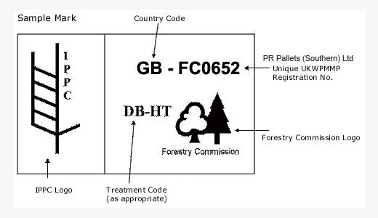

“Guidelines for Regulating Wood Packaging Material in International Trade” (**International Standards for Phytosanitary Measures ISPM 15**).

* + 1. Formaldehyde use is common in the adhesives for engineered wood products and is known to be a human carcinogen. It is the responsibility of the supplier to ensure all engineered wood used in shipping and packaging materials (pallets, crates, etc.) meet the emission regulations for the receiving Adient facility. See Emission Limits chart in Appendix 4.28.2 from TSCA Title VI from the EPA.
    2. Failure to comply with Government Regulations may have adverse liabilities. Any associated costs and/or fines incurred as a result will be the supplier’s responsibility.

4.4 Export Expendable Packaging standards for Overseas Shipments

* + 1. Transoceanic transportation modes commonly use 40” standard sea-container methods of transport.
    2. Packaging design specifications have been developed to standardize container dimensions and optimize cube efficiency in transportation. (For approved export carton/bulk container sizes see Appendix 4.28.1)
    3. Design and usage type of corrugated packaging material needs to be evaluated based on the method of transportation and handling through to the point of use.
    4. All expendable containers must be filled to maximize container density of 95% to maintain cubic fill and packaging integrity during handling, as well as optimized cubic freight.
    5. Export Pallets Footprint sizes are developed to maximum sea-container cubic utilization.
* 36 x 30 (in) = 915 x 762 (mm) 2-way
* 47 x 45 (in) = 1193 x 1143 (mm) 4-way
* 44.5 x 29.0 (in)= 1130 x 738(mm) 4-way (Adient A-Module)
* 44.5 x 46.5 (in) = 1130 x 1181 (mm) 4-way (Adient Z-module)
  + 1. All wooden pallets shipped must have flush stringer design and be assembled using cross ties. Full perimeter pallets are acceptable. **Single and double wing pallets are not allowed.**

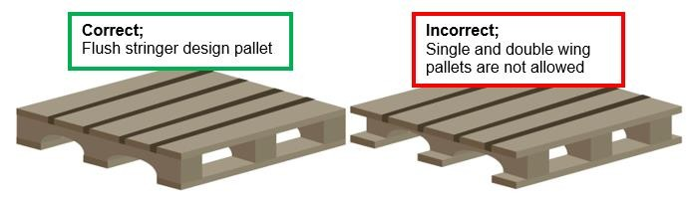

* + 1. All wooden pallets must be able to support a minimum of 2000 lb; (907 kg) internal load capacity.

4.5 Corrosion Prevention

* + 1. It is the responsibility of the supplier to properly protect parts susceptible to corrosion.
    2. Supplier should communicate/work with Product Engineering if rust inhibitor is required on the components.

4.6 Component/Production Labeling Requirements

4.6.1 Refer to SCM Global Supplier Standards Manual Section 4.5 Labeling Requirements for component label detail and locations

* Two (2) Production labels 4” x 6” per carton/container

4.7 Global Check list of the expectations

* + 1. The latest version of the Adient Global Supplier Standards Manual Supply Chain Management and Adient Global Supplier Packaging Standards and Requirements has been read and understood.
    2. Packaging was selected based on Adient Regional Best Practices and Standard container sizes and selecting the smallest container that fits the part. (See Appendix 4.29 for North America (USA, Mexico, Canada) and 4.30 for European (EMEA, Africa, APAC) Specific requirements)
* North America: 4.29.1 Adient N.A Standard commodity with best-in-class packaging recommendations
* Europe: 4.30.2 Europe Standard Container Matrix

4.7.3 Transoceanic/International shipping standards have been met:

* Compliant packaging sizes selected (See Appendix 4.28.1)
* Wood Packaging Materials meet the regional requirements (See Appendix 4.29.7 Adient Packaging Solid Wood Restrictions Memo – June 2017)

4.7.4Handheld containers meet the ergonomic weight restrictions of the customer regional location.

* North America: See section 4.10.3
* Europe: See section 4.19.3

